**LANDIS-II WILDLIFE HABITAT SUITABILITY EXTENSION PERFORMANCE TESTS**

General set-up: For each suitability model I created 3 wildlife habitat suitability extension files, testing the 2 suitability parameters separately and then together. When testing parameters separately, suitability for the non-tested parameter was set to 1 for all potential values. Establishment shade tolerance was set to 0 to prevent tree reproduction during simulations, as tree reproduction makes it difficult to track age classes. Test files begin with DJB in test folder.

**Suitability Model:** AgeClass_ForestType

**File:** DJBageclass_foresttype_exampleAge

**Parameter tested:** AgeClass

**Test definitions:** Suitability = 0 (0-10 YO), 2 (11-30 YO), and 0 (> 30 YO). Initial communities set to 10 YO, and maps output at 10 year intervals.

**Test:** Suitability should be 0 for the first map (10 YO), then 100 for the next 2 maps (20 and 30 YO), then 0 for maps thereafter (>30 YO).

**Results:** Test success.

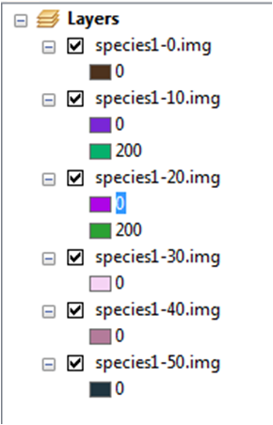

**Suitability Model:** AgeClass_ForestType

**File:** DJBageclass_foresttype_exampleFType

**Parameter tested:** ForestType

**Test definitions:** Suitability = 2 for MapleHardwood and 4 for Pine.

**Test:** Suitability should be 200 for MapleHardwood and 400 for Pine.

**Results:** Test success.

**Suitability Model:** AgeClass_ForestType

**File:** DJBageclass_foresttype_exampleAgeFType

**Parameter tested:** AgeClass and ForestType

**Test definitions:** Age suitability = 0 < 30 YO, and 1 ≥ 30 YO. Forest type suitability = 2 for MapleHardwood and 4 for Pine.

**Test:** Suitability should be 0 for the first two maps, then 200 for MapleHardwood or 400 for Pine thereafter.

**Results:** NOT YET TESTED

**Suitability Model:** AgeClass_TimeSinceFire

**File:** DJBageclass_tsf_exampleAge

**Parameter tested:** AgeClass

**Test definitions:** Suitability = 0 (0-10 YO), 2 (11-30 YO), and 0 (> 30 YO). Initial communities include jack pine and sugar maple, both set at 10 YO, and maps output at 10 year intervals.

**Test:** Suitability should be 0 for the first map (10 YO), 200 for maps 2 and 3 (20 and 30 YO), and 0 for maps thereafter.

**Results: Test Success!** 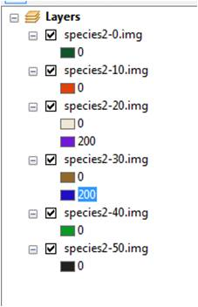

**Suitability Model:** AgeClass_TimeSinceFire

**File:** DJBageclass_tsf_exampleFire

**Parameter tested:** TimeSinceFire

**Test definitions:** Suitability = 0 for Severity Class 0 and 1 for Severity Class 1-5.

**Test:** Suitability should be 0 for non-burned areas and 100 for all burned areas.

**Results:** Test success. The first 2 maps show fire severity at 5 and 10 years, the 3rd map shows habitat suitability at year 10 of the simulation, which contains suitable habitat for the cells burned in the first 2 fire maps.

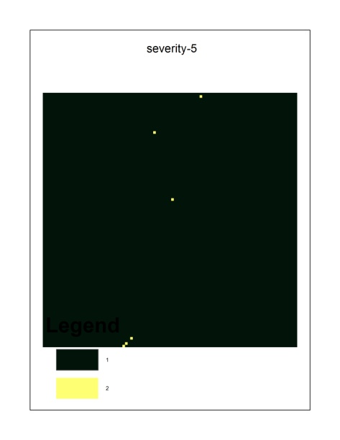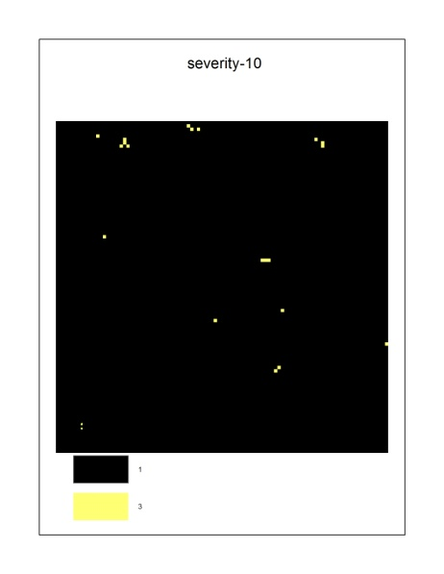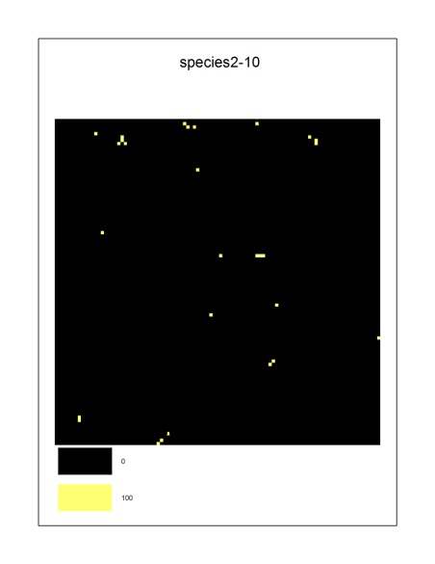

**Suitability Model:** AgeClass_TimeSinceFire

**File:** DJBageclass_tsf_exampleAgeFire

**Parameter tested:** Age andTimeSinceFire

**Test definitions:** Suitability = 0 (0-10 YO), 1 (11-30 YO), and 0 (> 30 YO). Suitability = 0 for Severity Class 0 and 2 for Severity Class 1-5.

**Test:** Suitability should be 0 for the first map (10 YO), 200 for the next two maps in cells that were burned (11-30 YO), and 0 for the remaining maps.

**Results:** Test fail. The maps are showing suitability for 30 and 40 YO trees rather than 20 and 30 YO trees (as expected, same error as the age test). Second, for the two maps showing suitable habitat, suitability should be additive and it’s not (see figures below; the habitat should stay suitable forever after fire until the max age is reached).

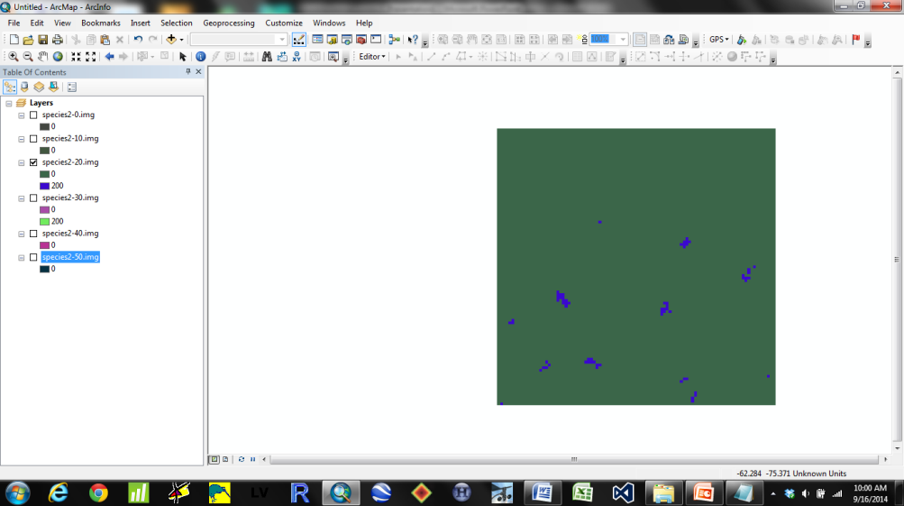

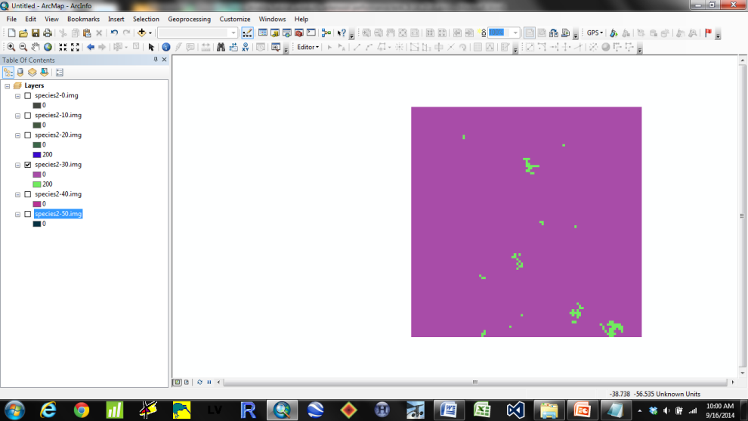

**Suitability Model:** AgeClass_TimeSinceHarvest

**File:** DJBageclass_tsh_exampleAge

**Parameter tested:** AgeClass

**Test definitions:** Suitability = 0 (0-10 YO), 2 (11-30 YO), and 0 (> 30 YO). Initial communities include jack pine and sugar maple, both set at 10 YO, and maps output at 10 year intervals.

**Test:** Suitability should be 0 for the first map (10 YO), 200 for maps 2 and 3 (20 and 30 YO), and 0 for maps thereafter.

**Results:** Test failed. Harvest suitability code was non-functional due to: “The given key was not present in the dictionary.” Looked at the code and couldn’t find an error.

**Suitability Model:** AgeClass_TimeSinceHarvest

**File:** DJBageclass_tsh_exampleHarvest

**Parameter tested:** TimeSinceHarvest

**Test definitions:** All trees harvested at 20 YO. Suitability = 0 for non-harvested trees (0-19 YO), and 2 for harvested trees (20+ YO).

**Test:** Suitability should be 0 for the first map (10 YO), and then 200 for maps thereafter (20+ YO).

**Results:** NOT YET TESTED

**Suitability Model:** AgeClass_TimeSinceHarvest

**File:** DJBageclass_tsh_exampleAgeHarvest

**Parameter tested:** Age and TimeSinceHarvest

**Test definitions:** Age suitability = 0 (0-10 YO), 2 (11-30 YO), and 0 (> 30 YO). Harvest suitability = 0 for non-harvested trees (0-19 YO), and 2 for harvested trees (20+ YO).

**Test:** Suitability should be 0 for the first map (10 YO), 400 for cells that were harvested when trees were 11-30 YO, and 0 for the remaining maps.

**Results:** NOT YET TESTED

**Suitability Model:** ForestType_TimeSinceFire

**File:** DJBforesttype_tsf_exampleFType

**Parameter tested:** ForestType

**Test definitions:** Suitability = 2 for sugar maple and 4 for jack pine.

**Test:** Suitability should be 200 for sugar maple and 400 for jack pine.

**Results:** Test failed. Like with the *AgeClass_ForestType* suitability model, it appears that the species are not being reclassified to forest types. Also, habitat suitability output is 0 for all cells and time periods.

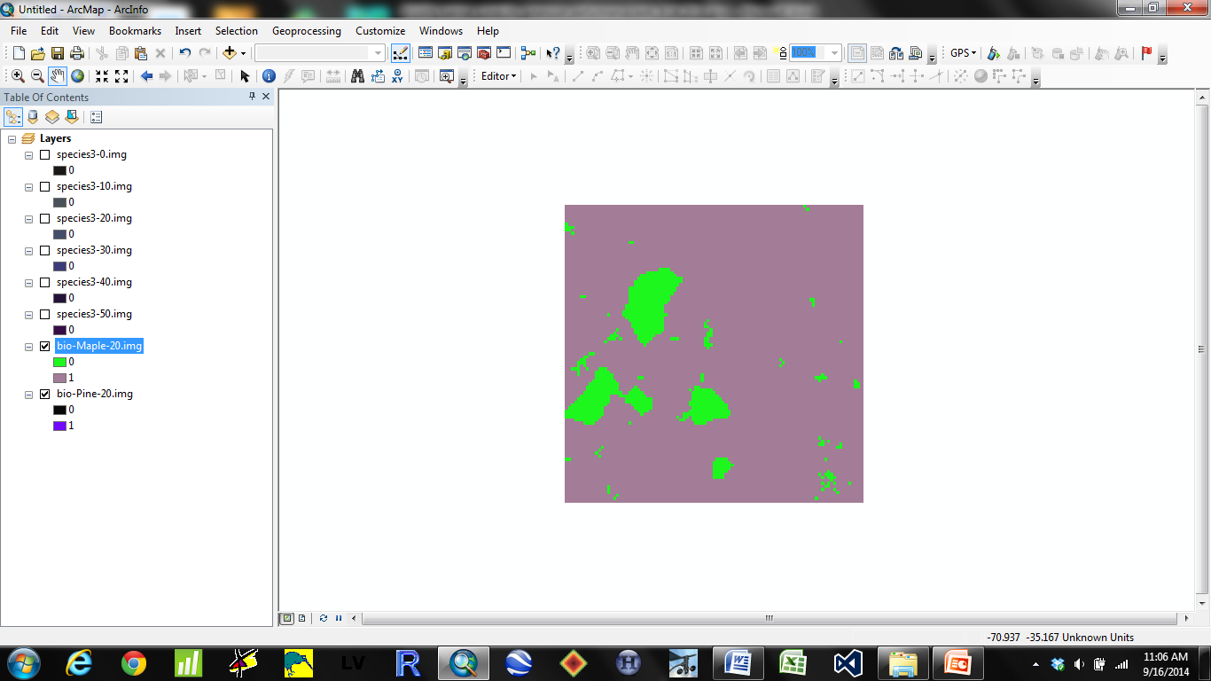

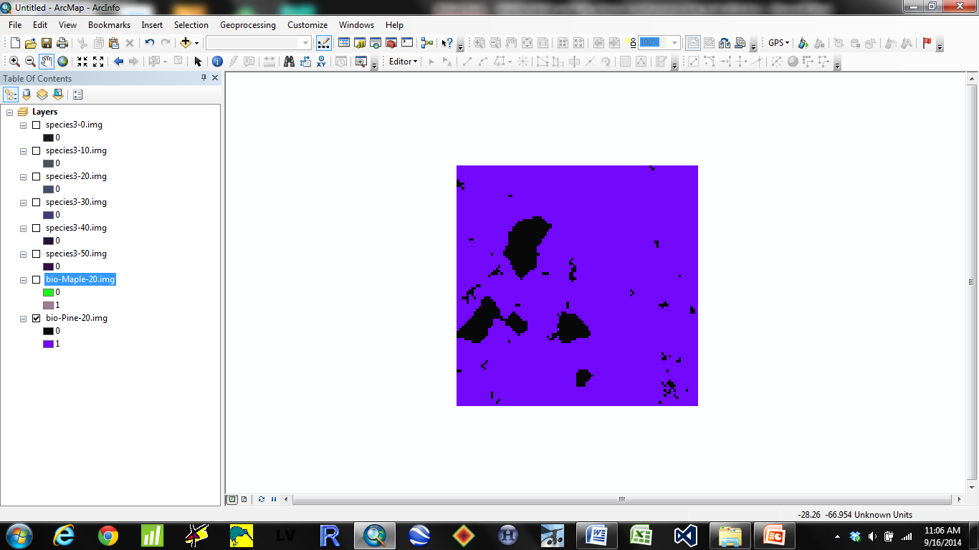

**Suitability Model:** ForestType_TimeSinceFire

**File:** DJBforesttype_tsf_exampleTimeSinceFire

**Parameter tested:** TimeSinceFire

**Test definitions:** Suitability = 0 for Severity Class 0 and 1 for Severity Class 1-5.

**Test:** Suitability should be 0 for non-burned areas and 100 for all burned areas.

**Results:** Test success. The first 2 maps show fire severity at 5 and 10 years, the 3rd map shows habitat suitability at year 10 of the simulation, which contains suitable habitat for the cells burned in the first 2 fire maps.

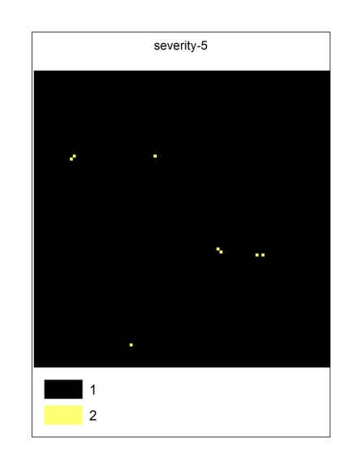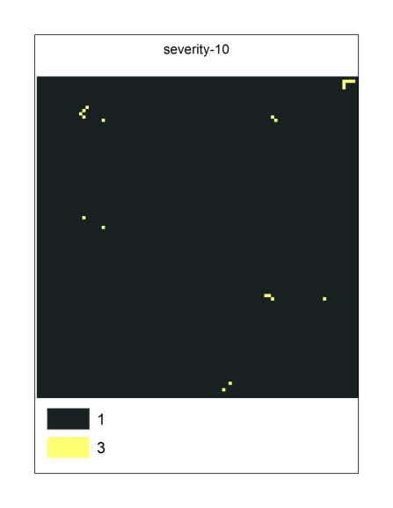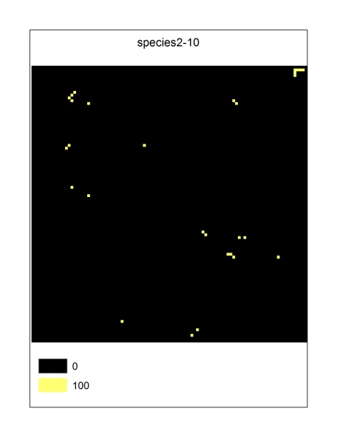

**Suitability Model:** ForestType_TimeSinceFire

**File:** DJBforesttype_tsf_exampleFTypeTimeSinceFire

**Parameter tested:** ForestType and TimeSinceFire

**Test definitions:** Suitability = 2 for sugar maple and 4 for jack pine. Suitability = 0 for Severity Class 0 and 1 for Severity Class 1-5.

**Test:** Suitability should be 200 and 400 for sugar maple and jack pine sites burned each year, and stay suitable through time. Total habitat suitability should increase through time as more fires occur.

**Results:** NOT YET TESTED

**Suitability Model:** ForestType_TimeSinceHarvest

**File:** DJBforesttype_tsh_exampleFType

**Parameter tested:** ForestType

**Test definitions:** Suitability = 2 for sugar maple and 4 for jack pine.

**Test:** Suitability should be 200 for sugar maple and 400 for jack pine.

**Results:** NOT YET TESTED, HARVEST MODEL NON_FUNCTIONAL

**Suitability Model:** ForestType_TimeSinceHarvest

**File:** DJBforesttype_tsh_exampleTimeSinceHarvest

**Parameter tested:** TimeSinceHarvest

**Test definitions:** All trees harvested at 20 YO. Suitability = 0 for non-harvested trees (0-19 YO), and 2 for harvested trees (20+ YO).

**Test:** Suitability should be 0 for the first map (10 YO), and then 200 for maps thereafter (20+ YO).

**Results:** NOT YET TESTED, HARVEST MODEL NON_FUNCTIONAL

**Suitability Model:** ForestType_TimeSinceHarvest

**File:** DJBforesttype_tsh_exampleFTypeTimeSinceHarvest

**Parameter tested:** ForestType and TimeSinceHarvest

**Test definitions:** Suitability = 2 for sugar maple and 4 for jack pine. All trees harvested at 20 YO. Harvest suitability = 0 for trees <20 YO, 2 for trees ≥20 YO.

**Test:** Suitability should be 0 for the first map (10 YO), and then 400 for sugar maple cells and 800 for jack pine cells thereafter that were harvested.

**Results:** NOT YET TESTED